Tour ID: 259071  
Tour Name: The Heart of Greenland | Disko Bay

Tour destinations: ['Reykjavik']

Tour destinations images:

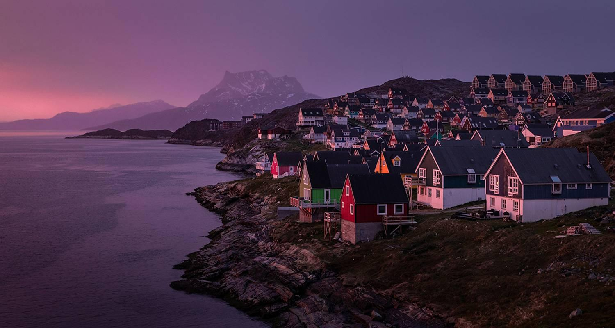

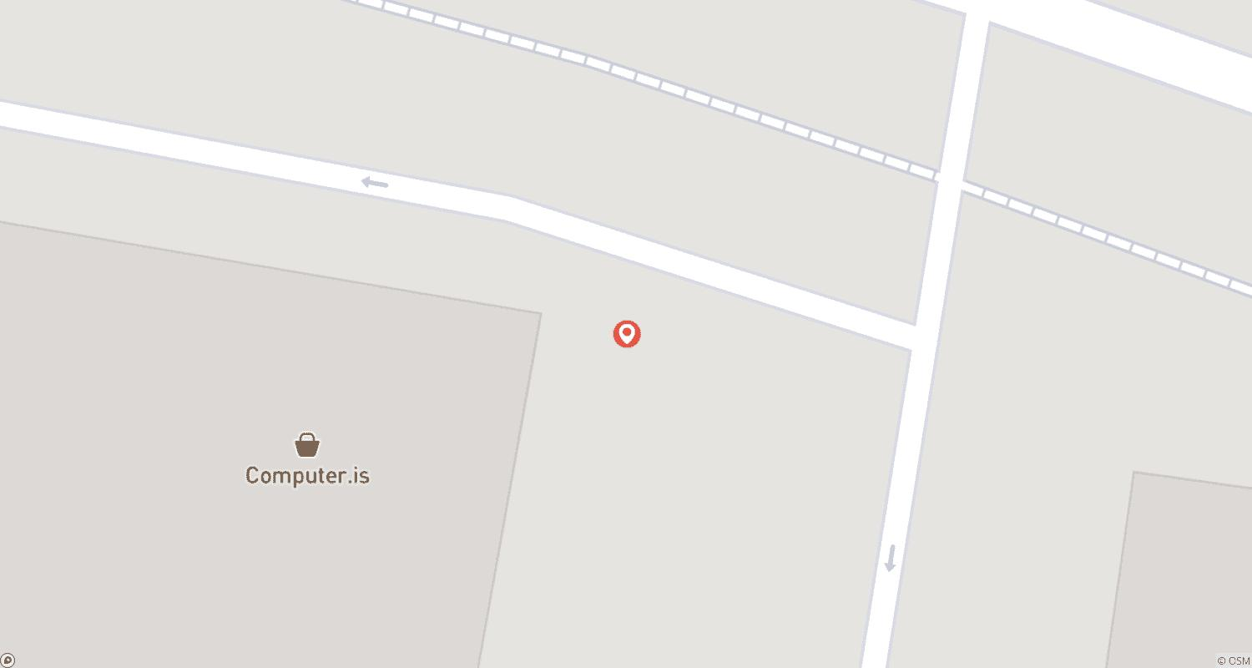

Tour ID: 259087  
Tour Name: Wild Islands of the North Atlantic | Reykjavík to Hamburg (2024)

Tour destinations: ['Reykjavik', 'Heimaey Island', 'Snæfellsnes', 'Patreksfjordur', 'Akureyri', 'Godafoss', 'Grimsey', 'Seydisfjordur', 'Runavík', 'Streymoy Island', 'Lerwick', 'Fair Isle', 'Edinburgh', 'Hamburg']

Tour destinations images:

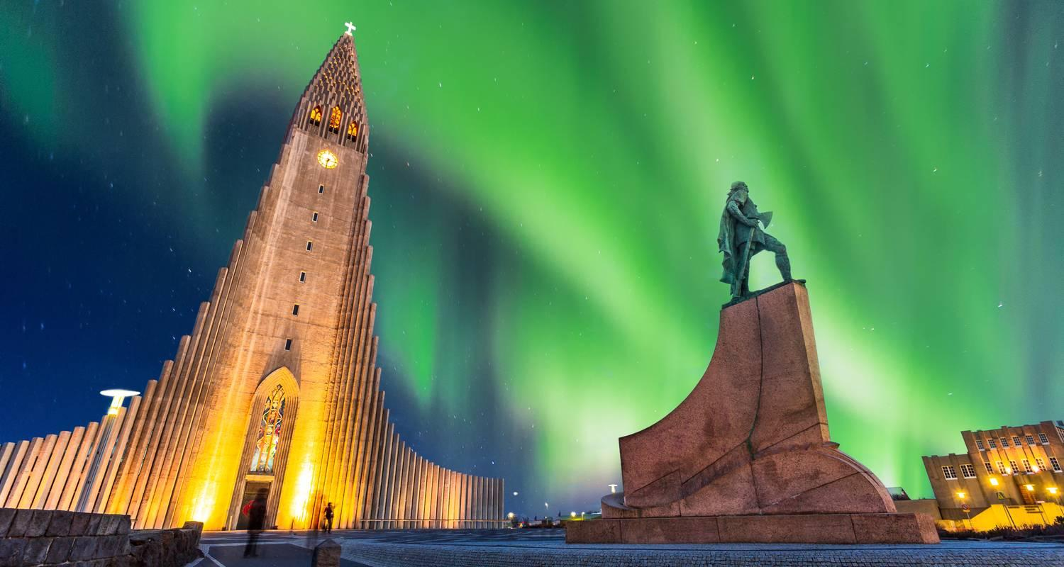

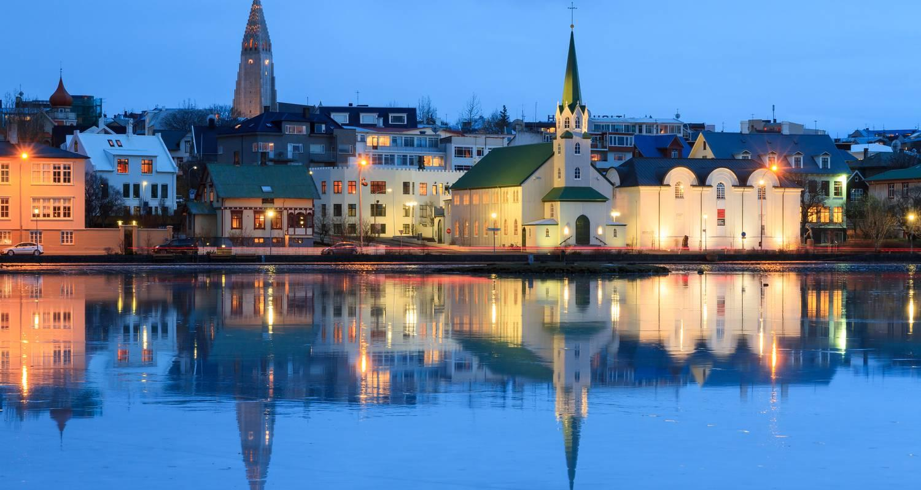

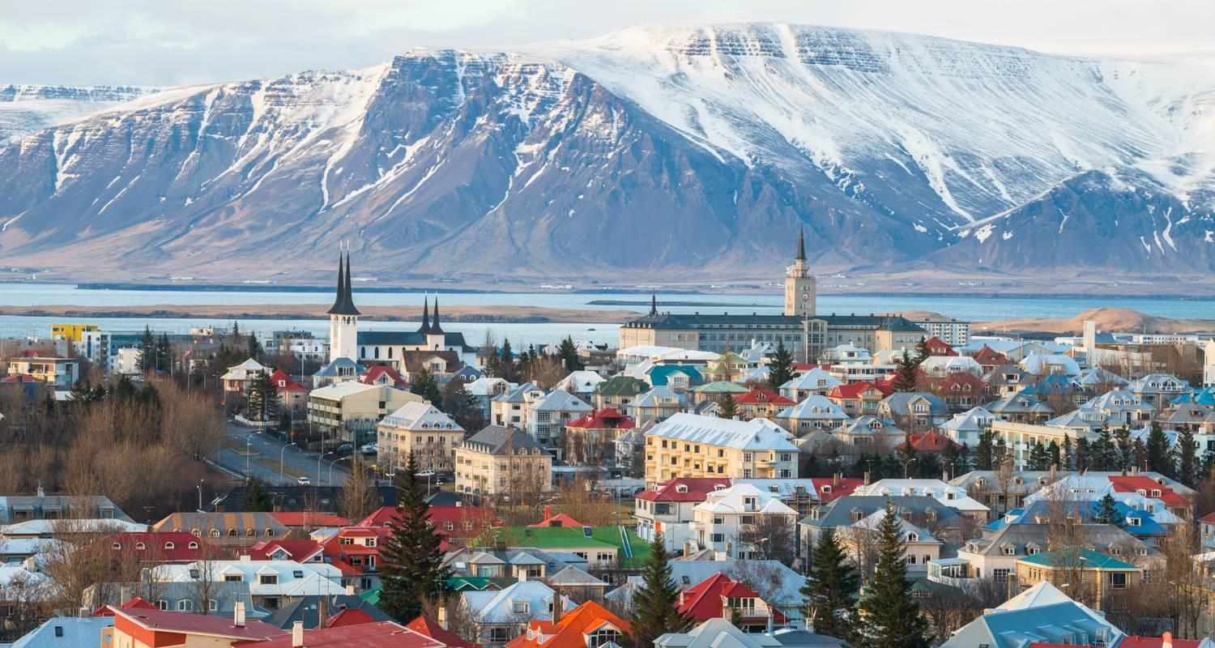

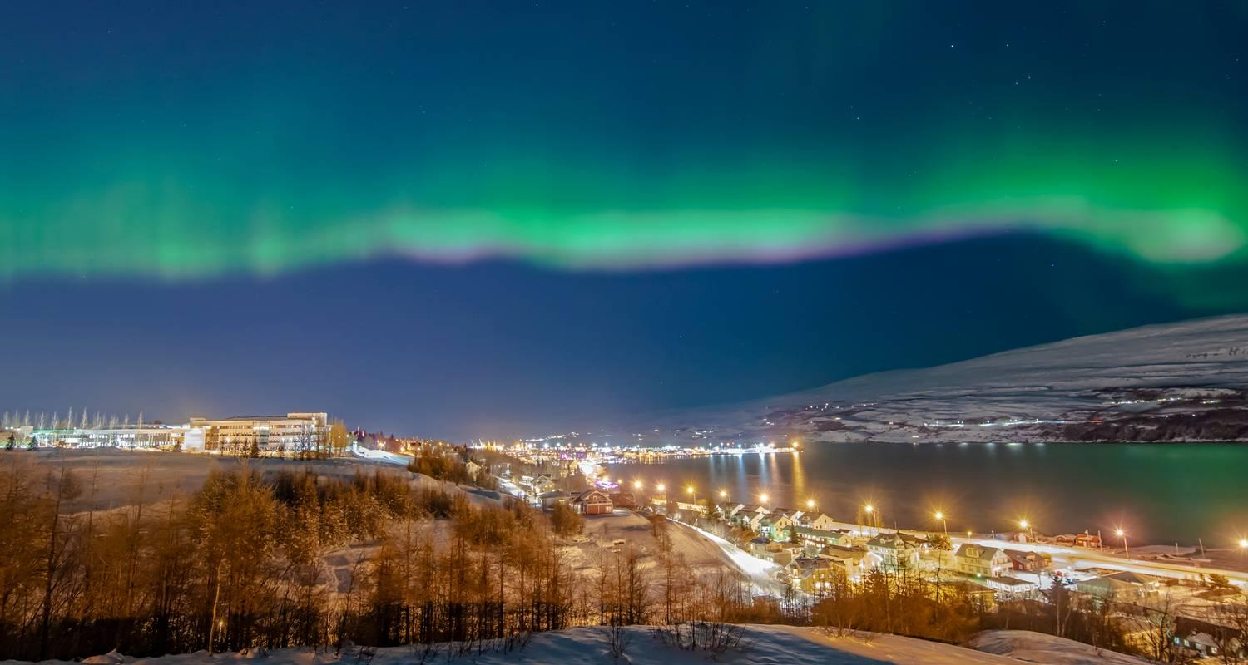

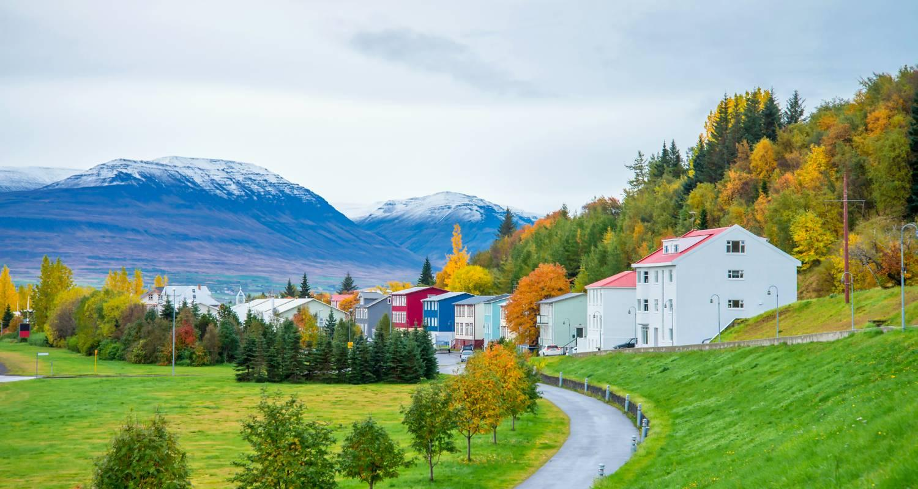

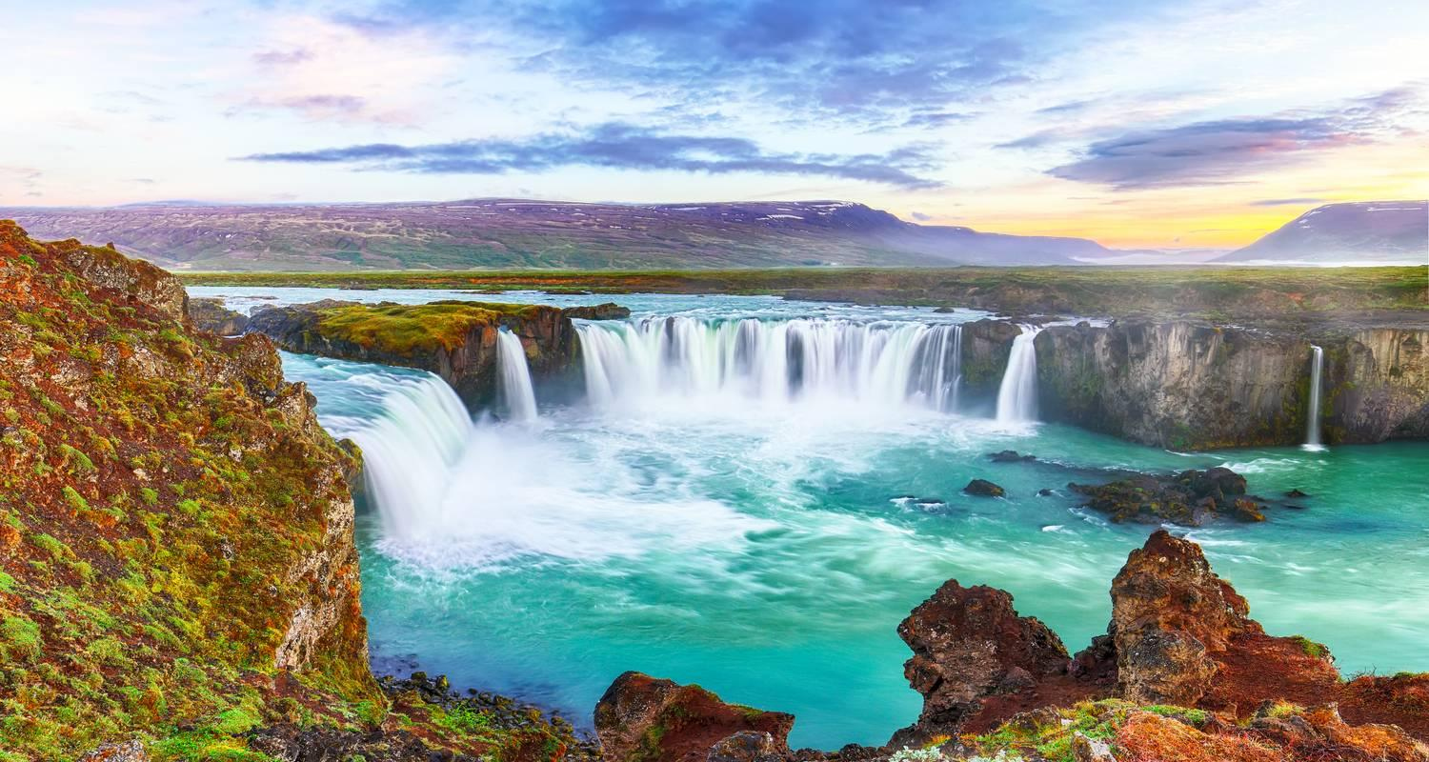

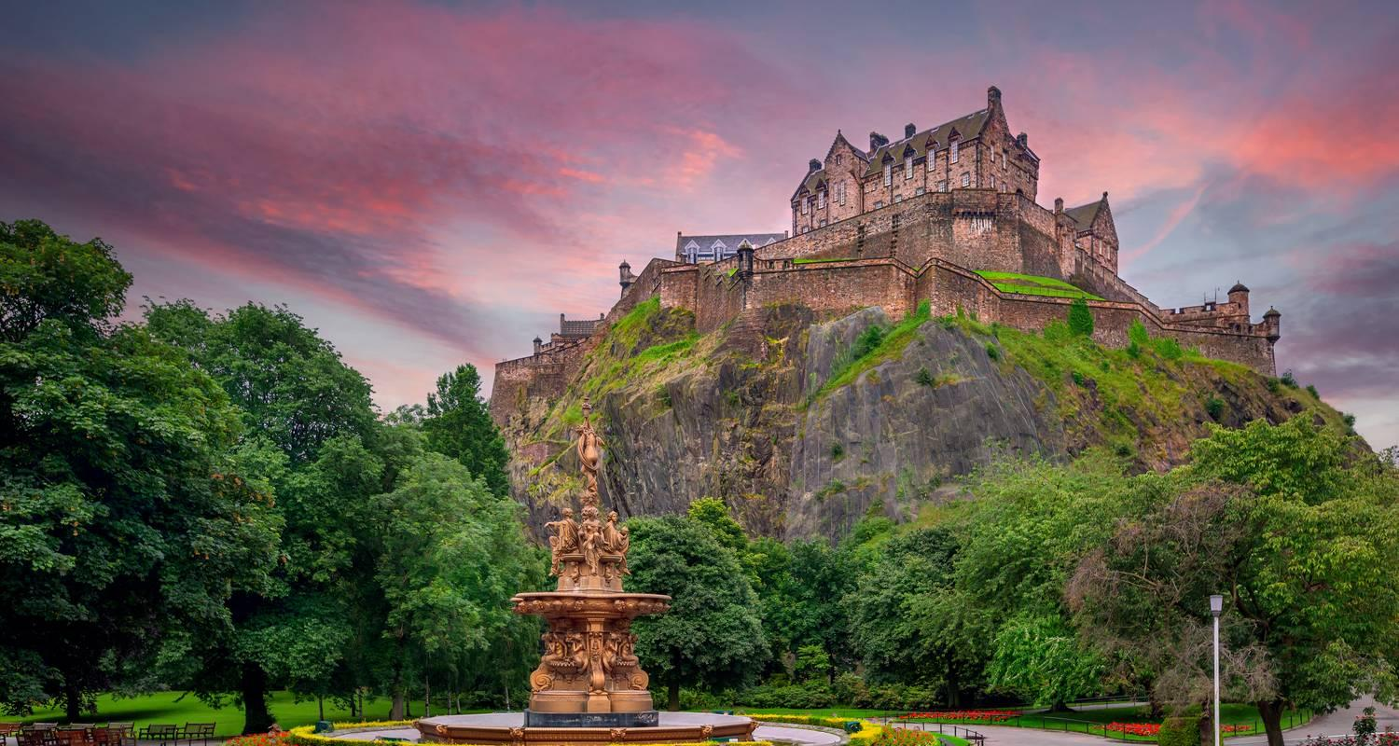

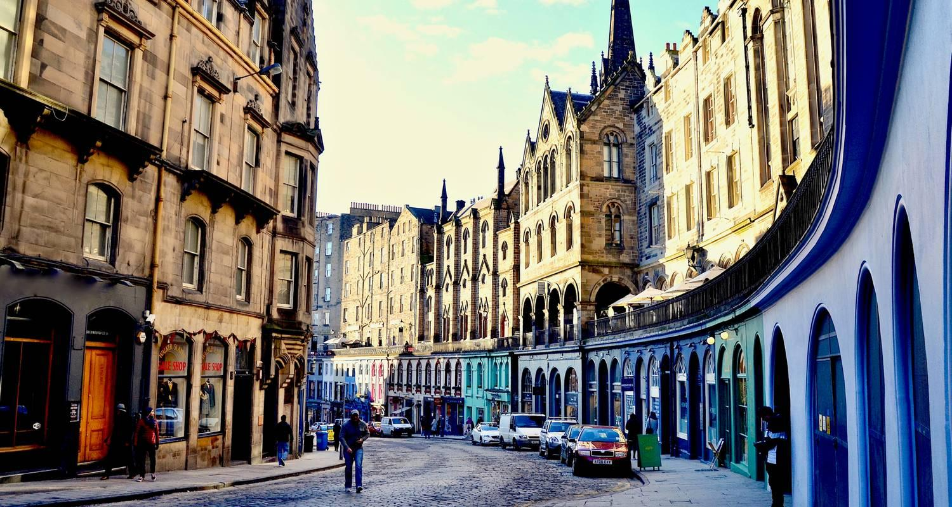

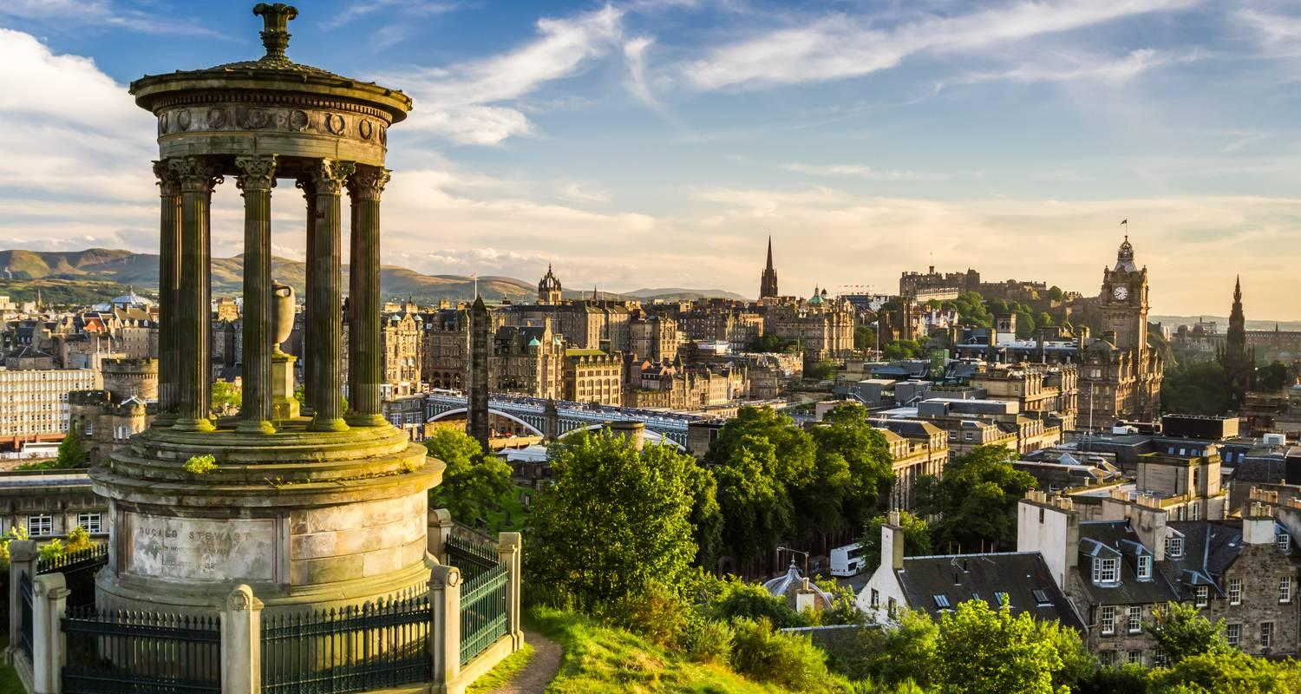

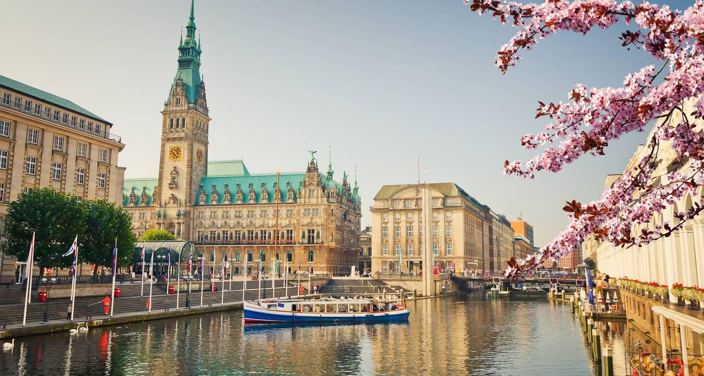

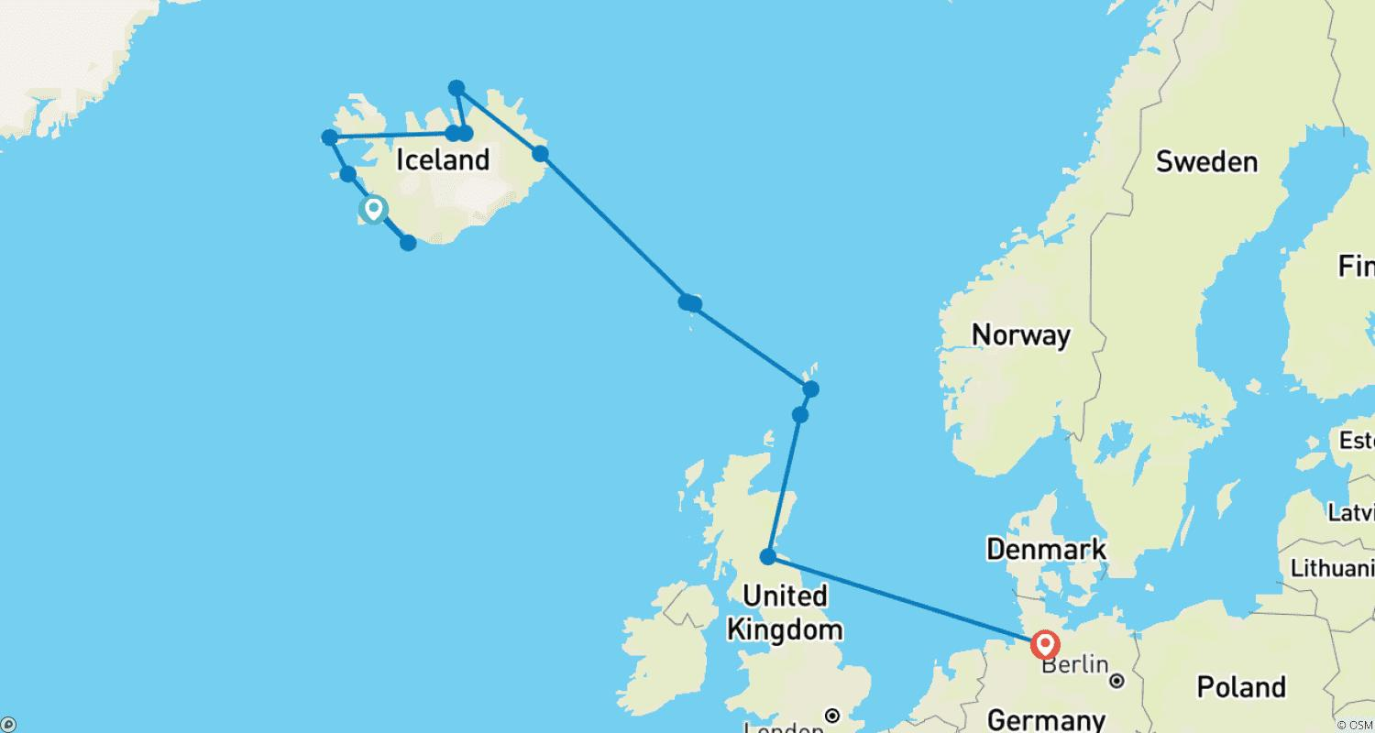

Tour ID: 259093  
Tour Name: The Land of Elves, Sagas & Volcanoes | Circumnavigating Iceland: Itinerary 2

Tour destinations: ['Reykjavik', 'Snæfellsnes', 'Stykkisholmur', 'Blue Lagoon', 'Akureyri', 'Husavik']

Tour destinations images:

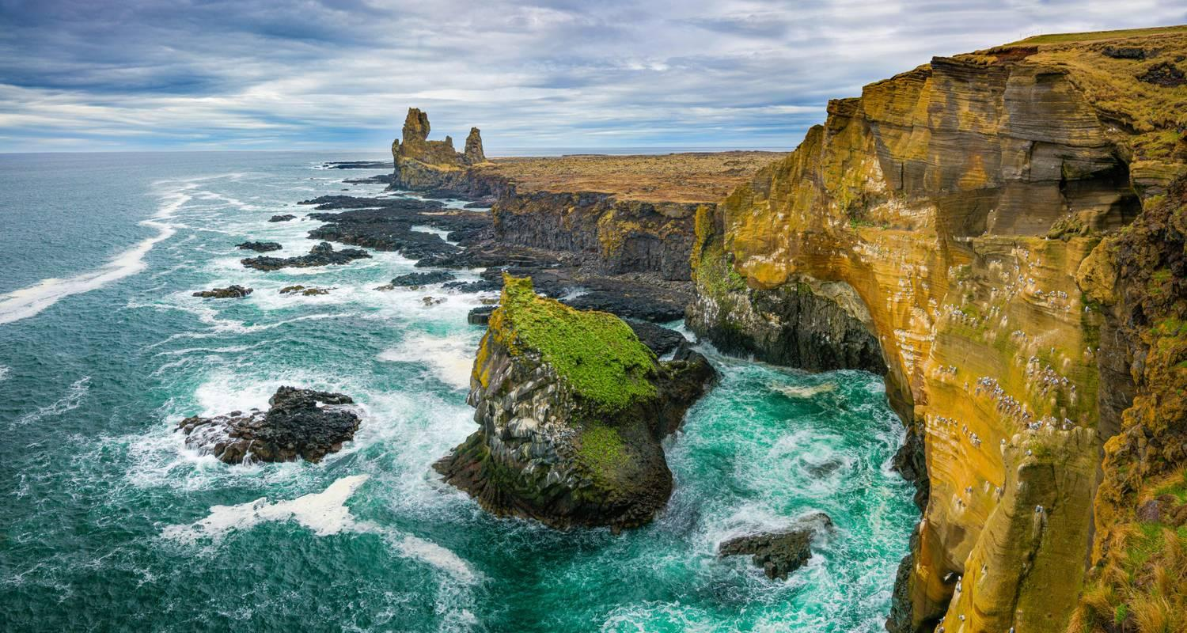

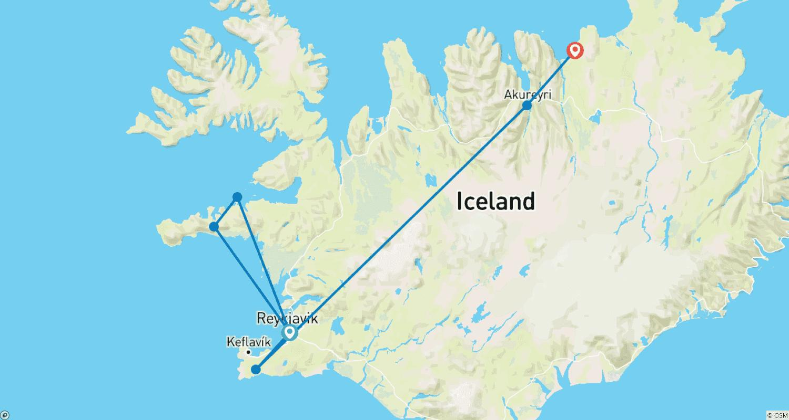

Tour ID: 259102  
Tour Name: The Ultimate Fjord Expedition

Tour destinations: ['Reykjavik']

Tour destinations images:

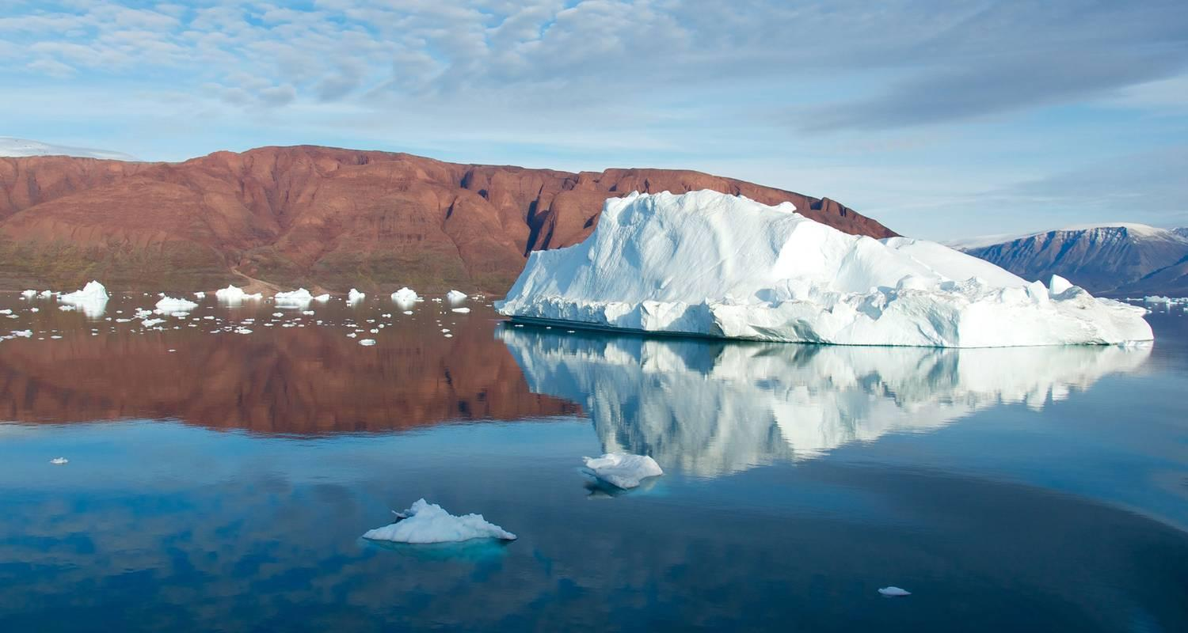



Tour ID: 259104  
Tour Name: The Land of Elves, Sagas & Volcanoes | Circumnavigating Iceland: Itinerary 1

Tour destinations: ['Reykjavik', 'Stykkisholmur', 'Snæfellsnes', 'Akureyri', 'Blue Lagoon']

Tour destinations images:

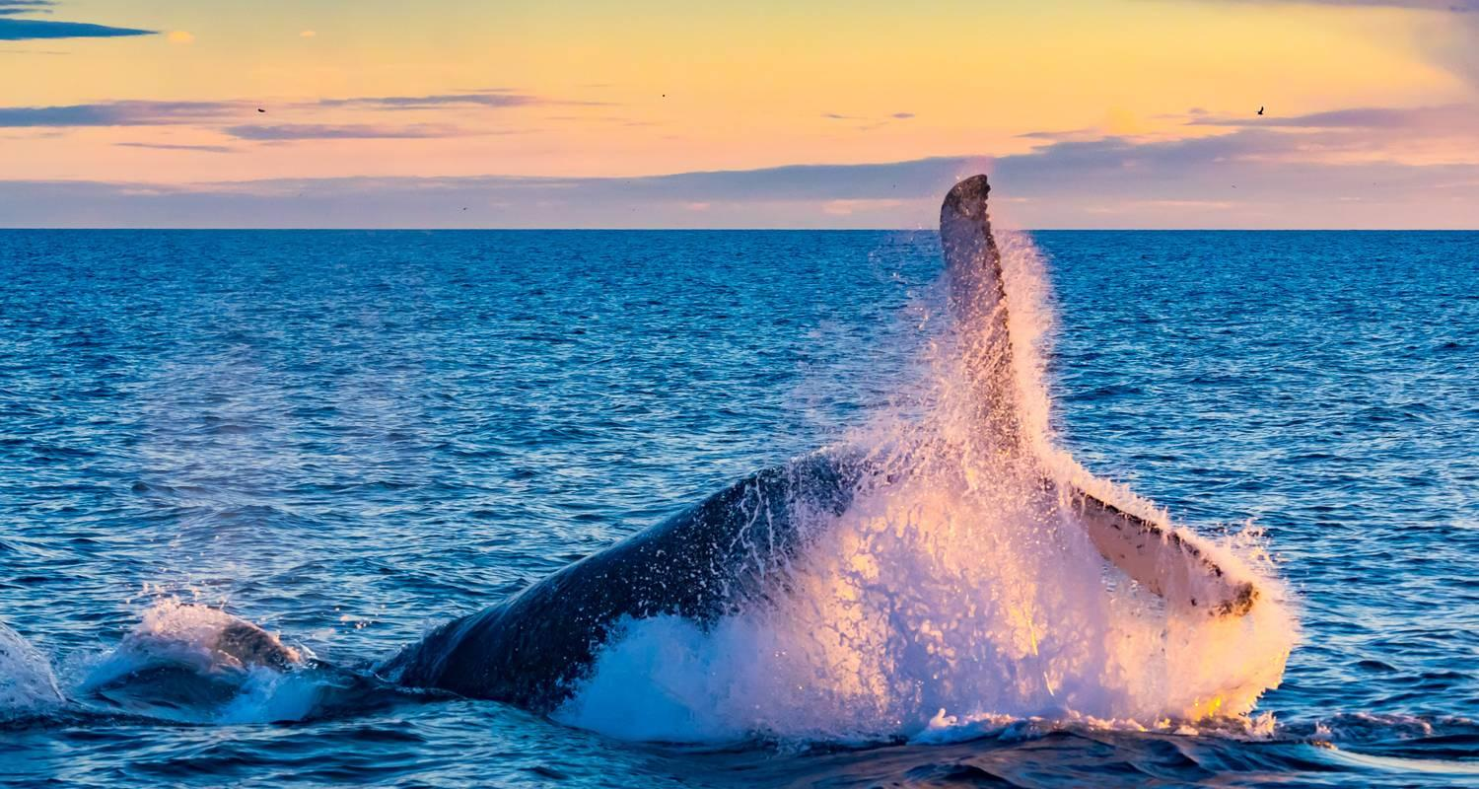

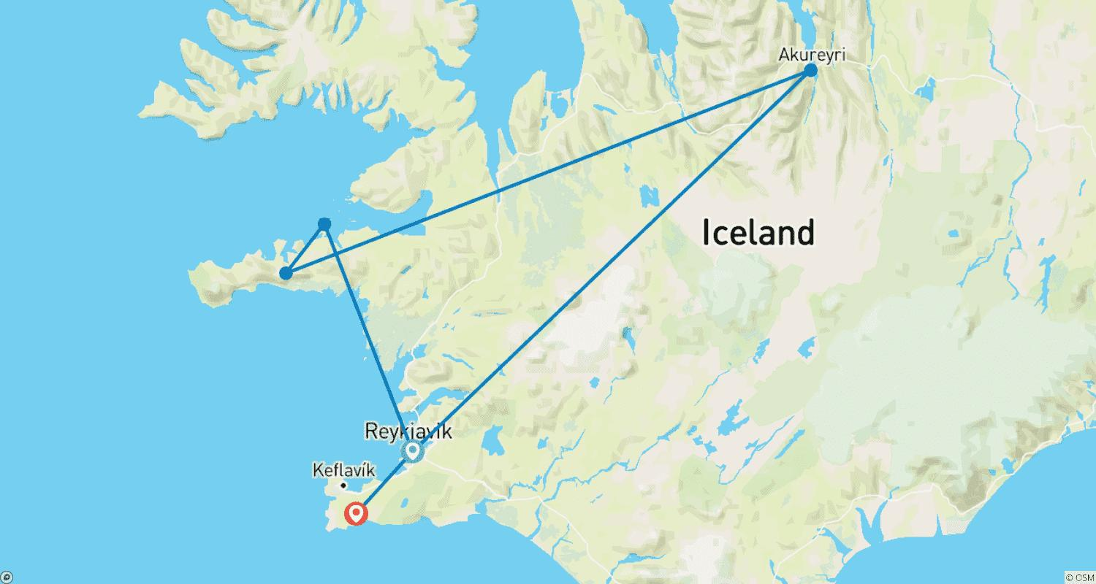

Tour ID: 259119  
Tour Name: Island Hopping in the North Atlantic | British Isles, Faroe Islands & Iceland: Northbound

Tour destinations: ['Dover', 'Edinburgh', 'Orkney Islands', 'Kirkwall', 'Skara Brae', 'Fair Isle', 'Shetland Islands', 'Torshavn', 'Runavík', 'Heimaey Island', 'Reykjavik']

Tour destinations images:

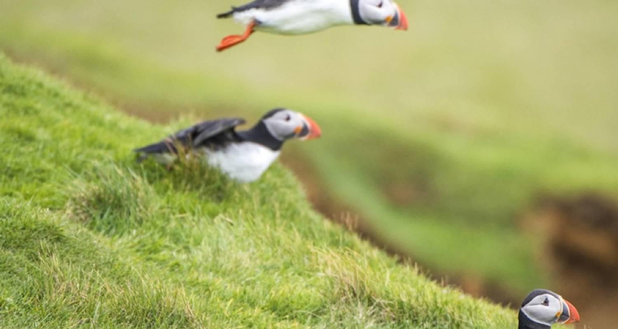



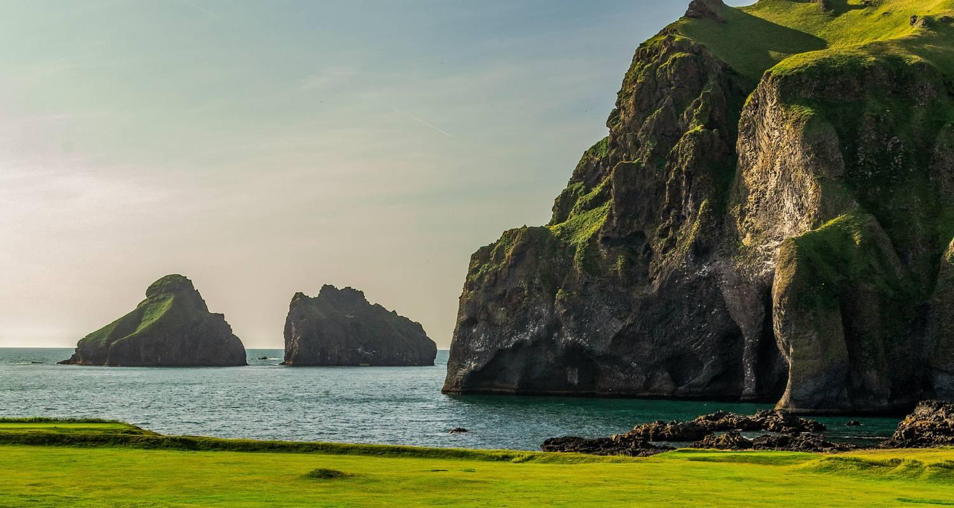

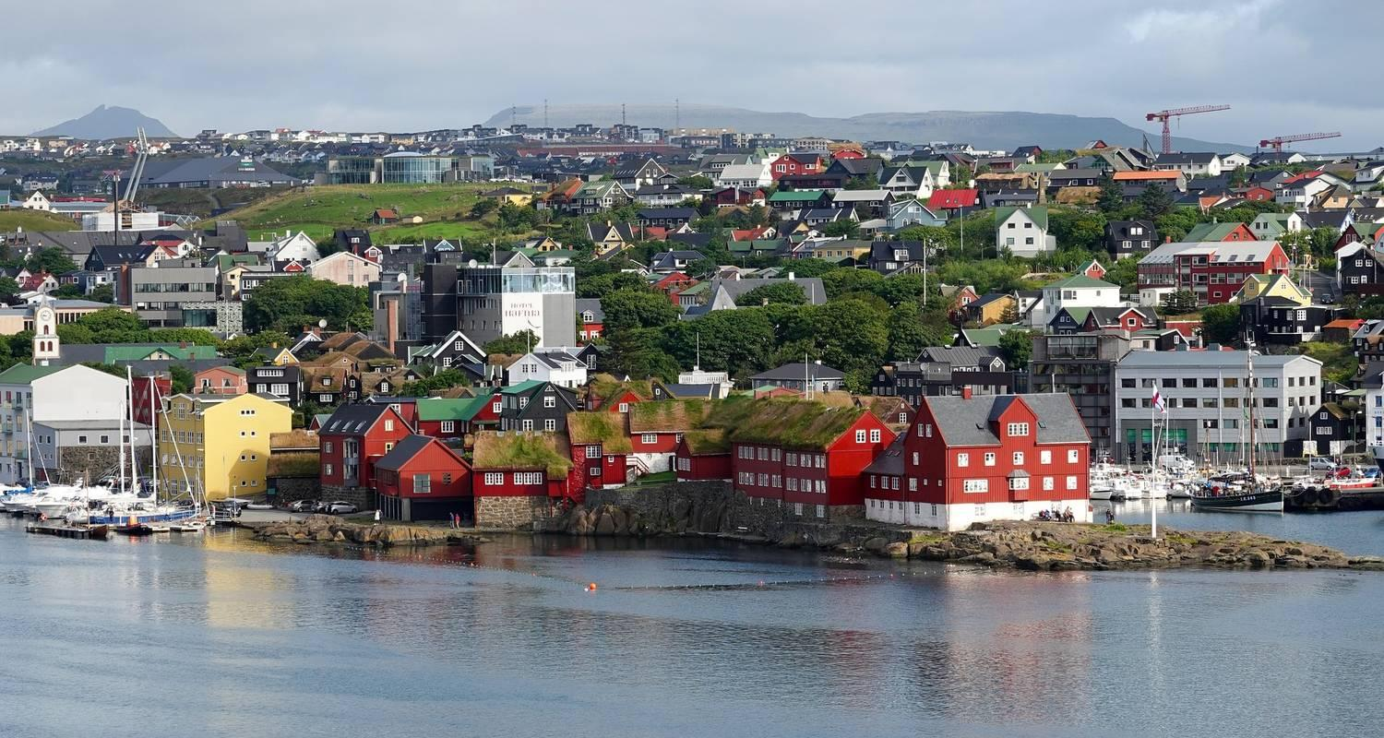

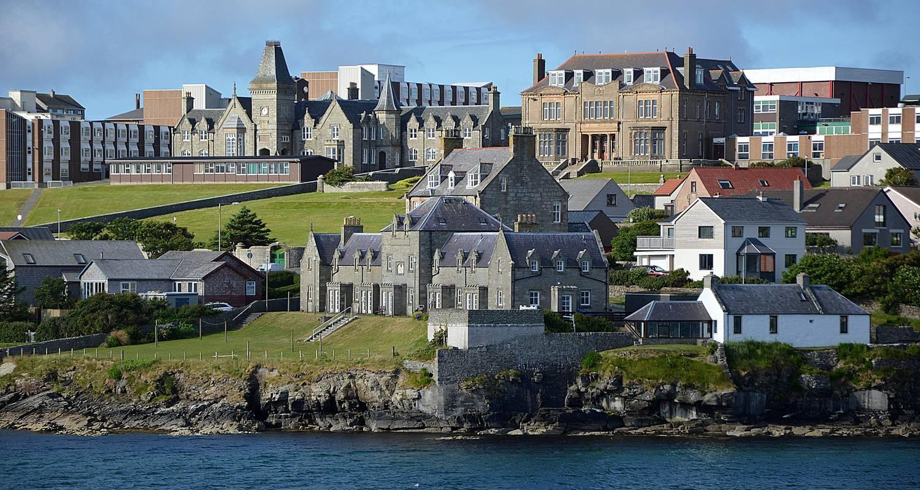

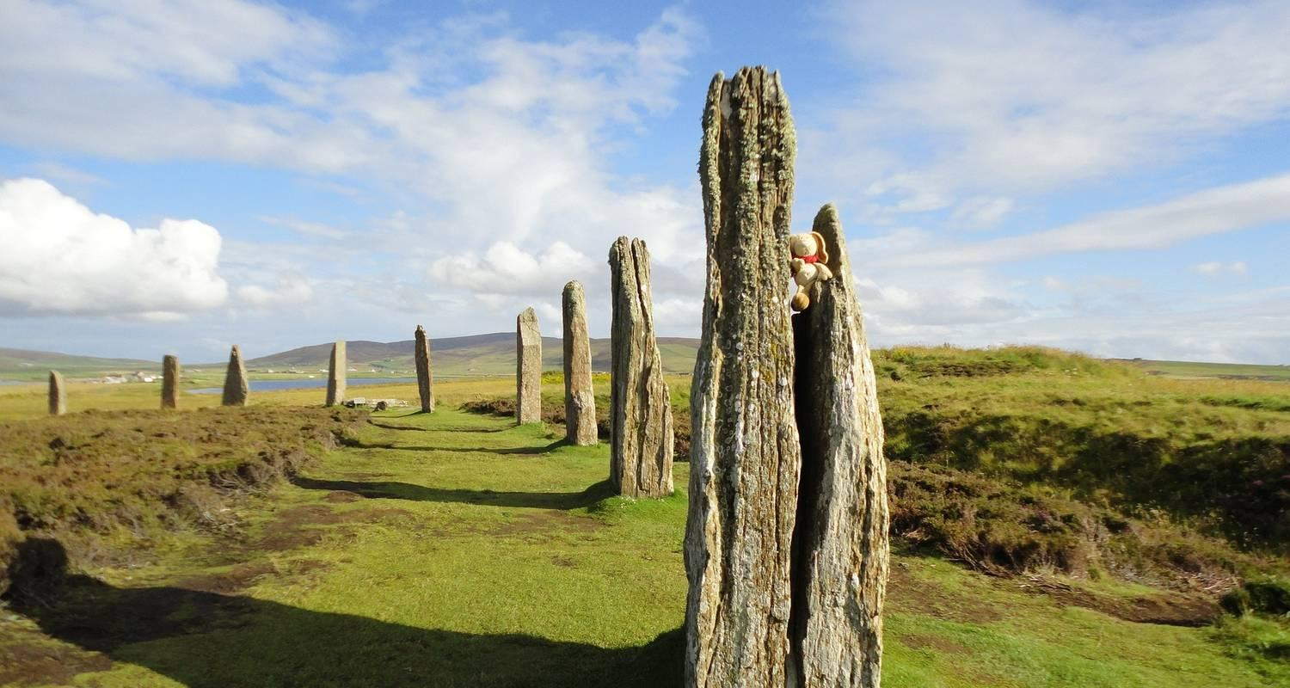

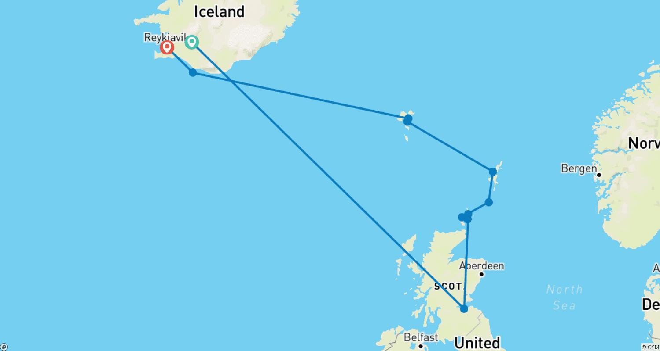

Tour ID: 259120  
Tour Name: Arctic Islands Discovery | Iceland, Jan Mayen, Spitsbergen: Eastbound

Tour destinations: ['Reykjavik', 'Blue Lagoon', 'Snæfellsnes', 'Akureyri', 'Godafoss', 'Myvatn', 'Grimsey', 'Jan Mayen Island', 'Svalbard', 'Nordvest-Spitsbergen National Park', 'Longyearbyen']

Tour destinations images:

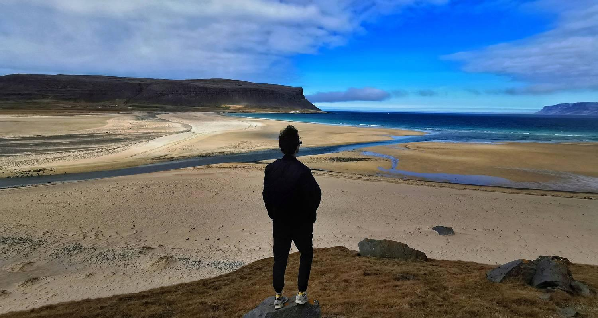

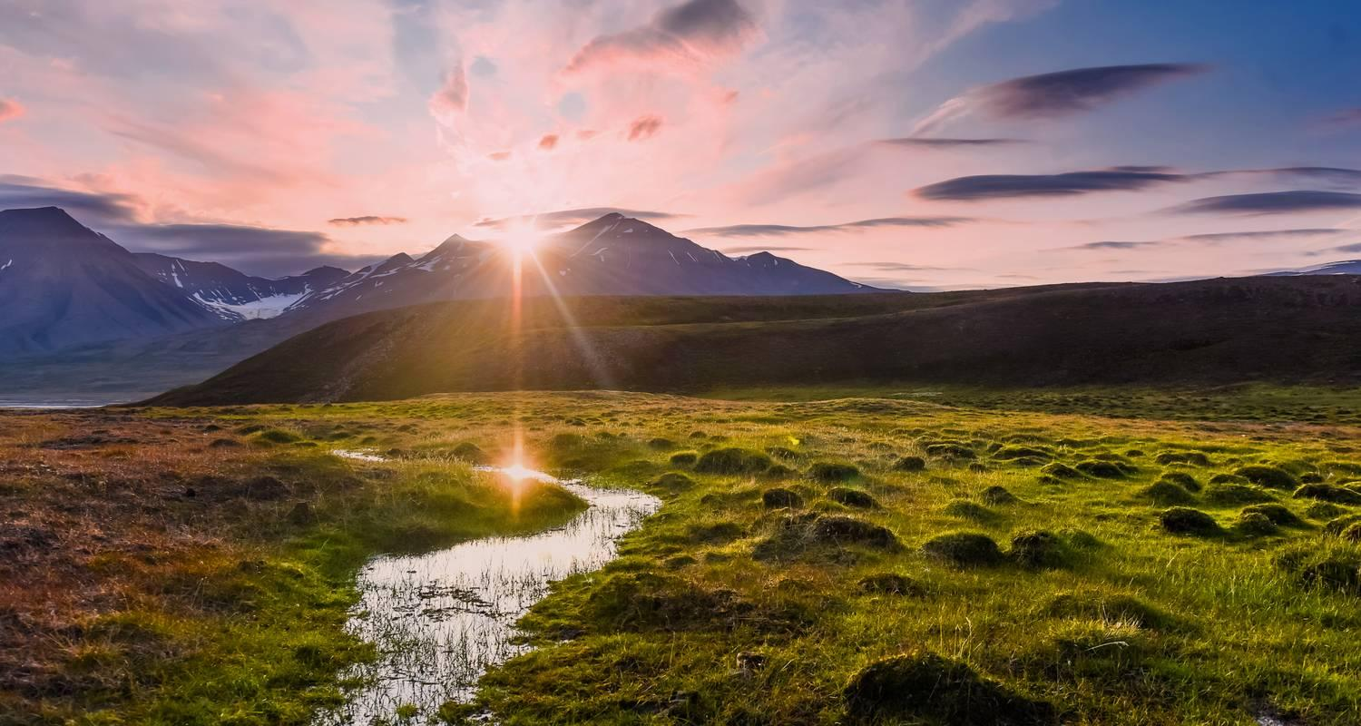





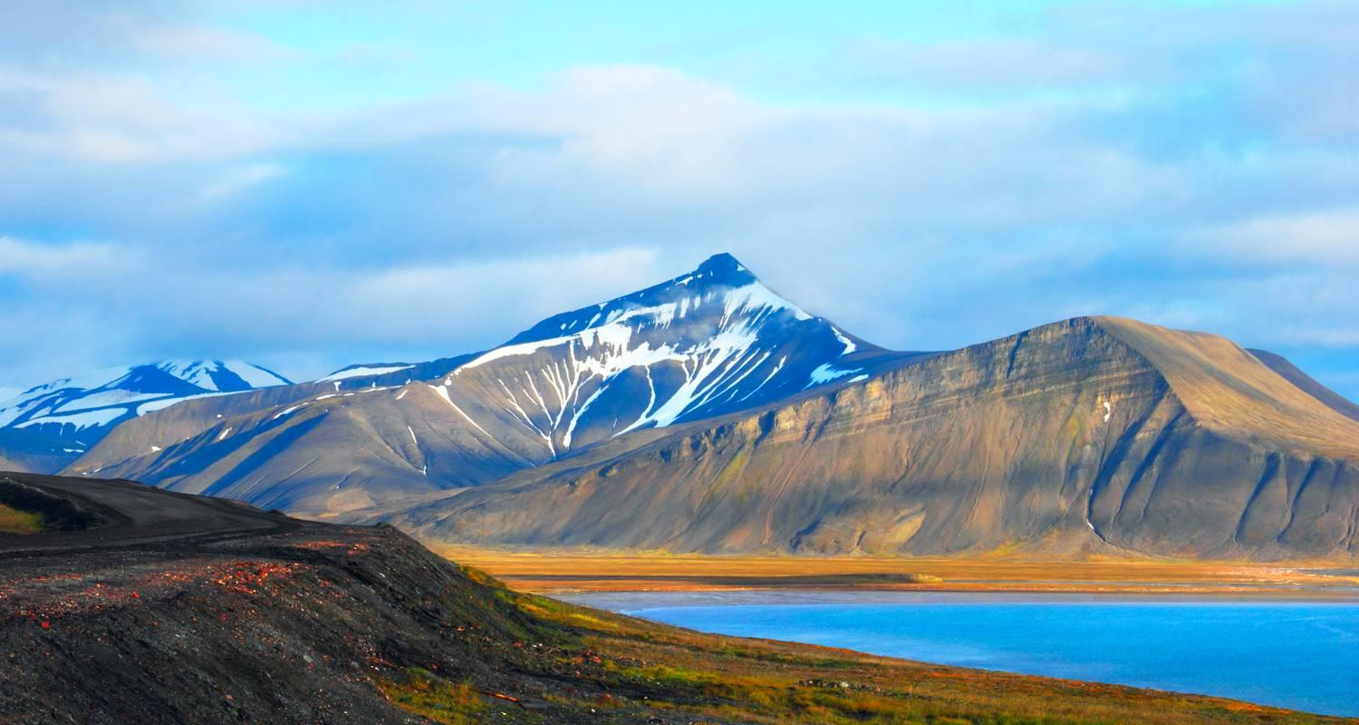

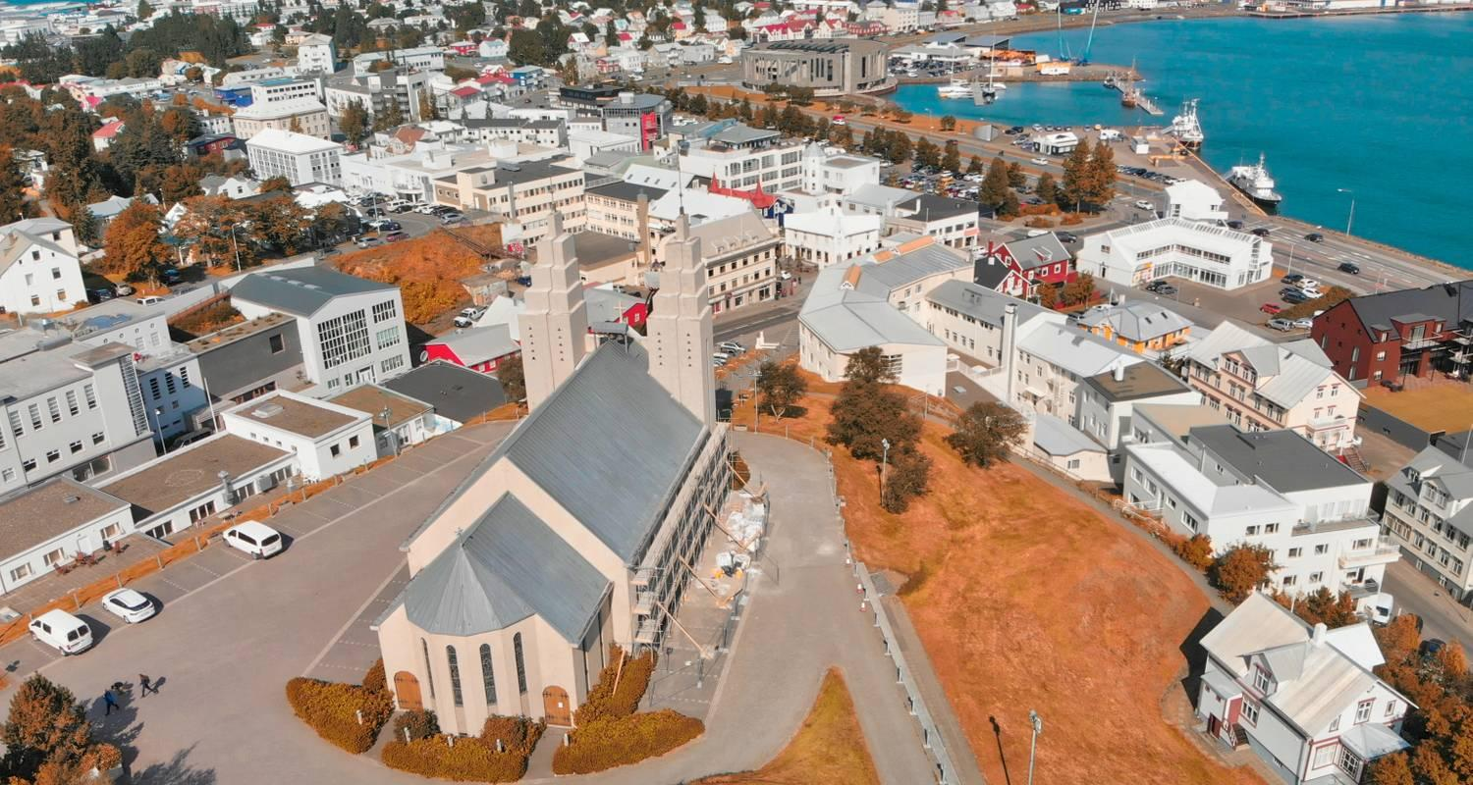



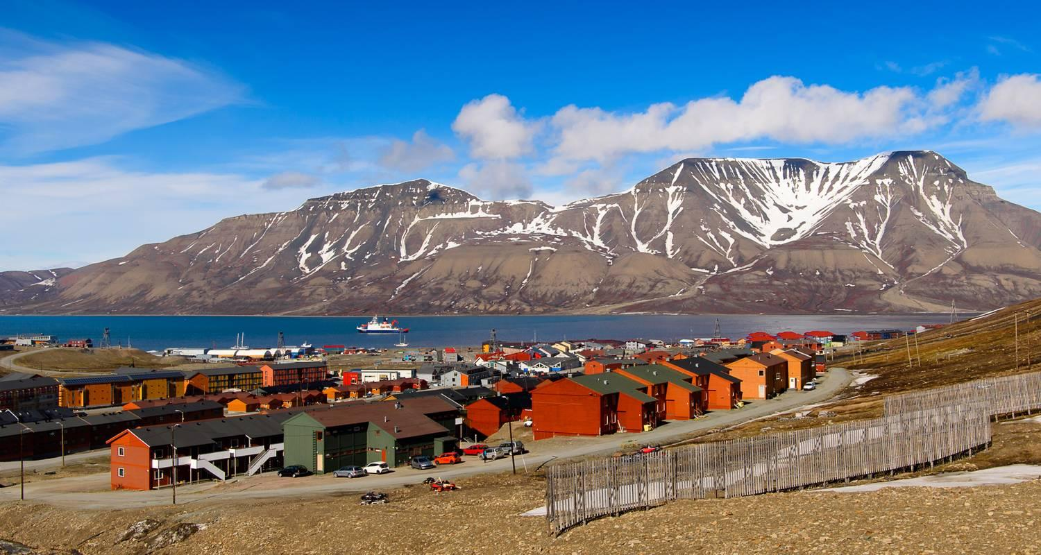

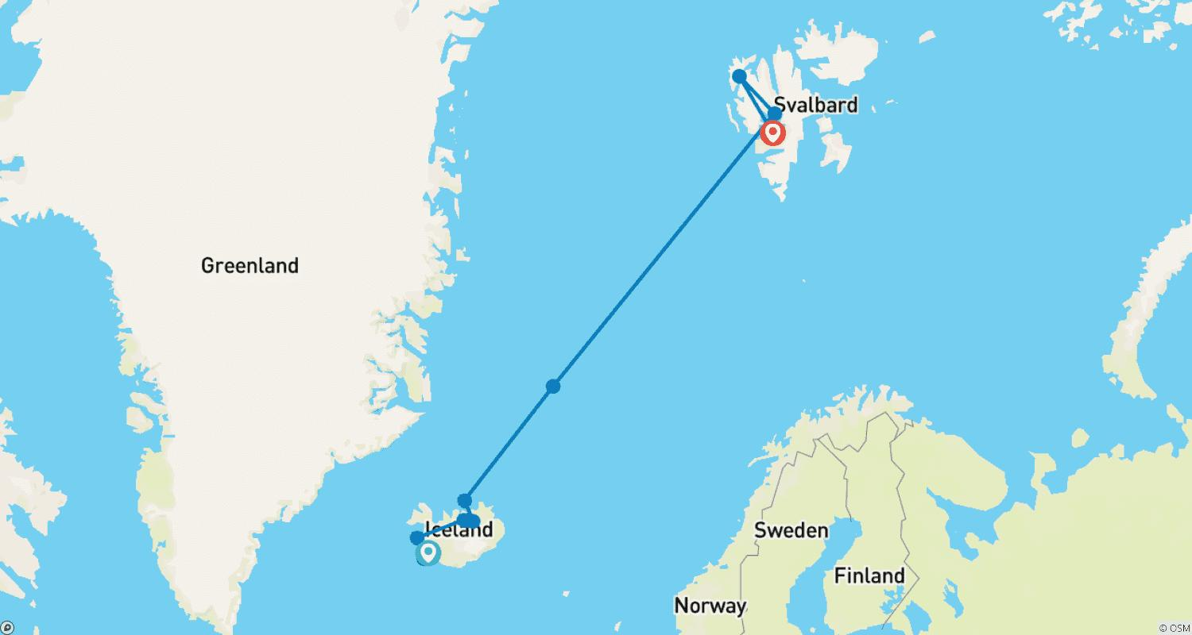

Tour ID: 259123  
Tour Name: Arctic Islands Discovery | Spitsbergen, Jan Mayen, Greenland, Iceland: Westbound

Tour destinations: ['Oslo', 'Longyearbyen', 'Nordvest-Spitsbergen National Park', 'Jan Mayen Island', 'Scoresby Sound', 'Stykkisholmur', 'Snæfellsnes', 'Reykjavik']

Tour destinations images:

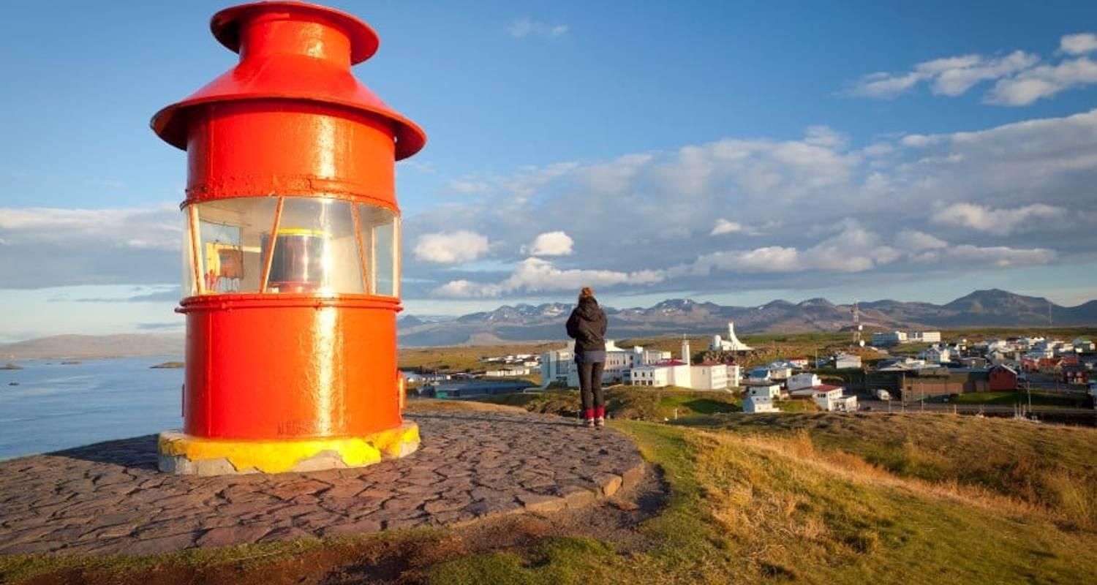

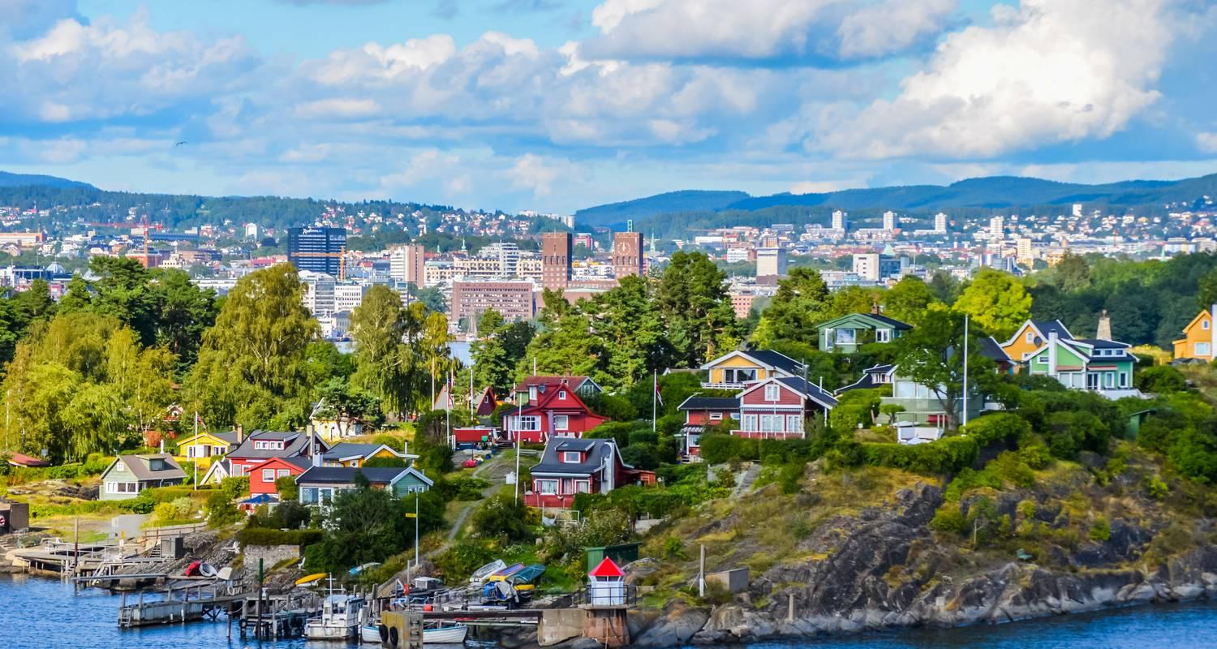



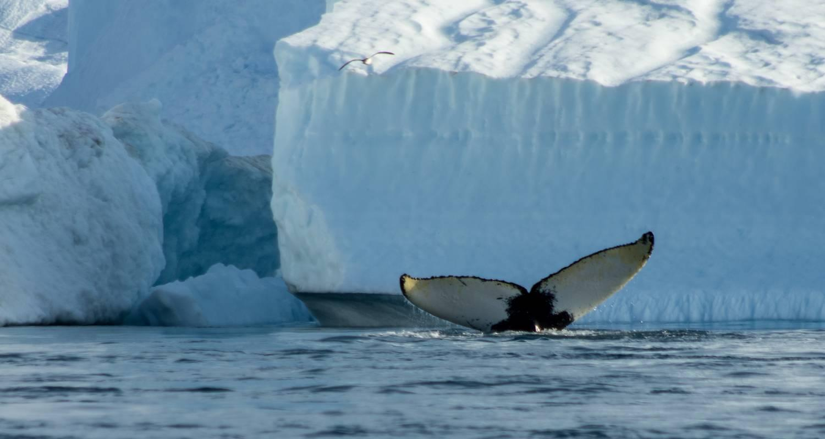

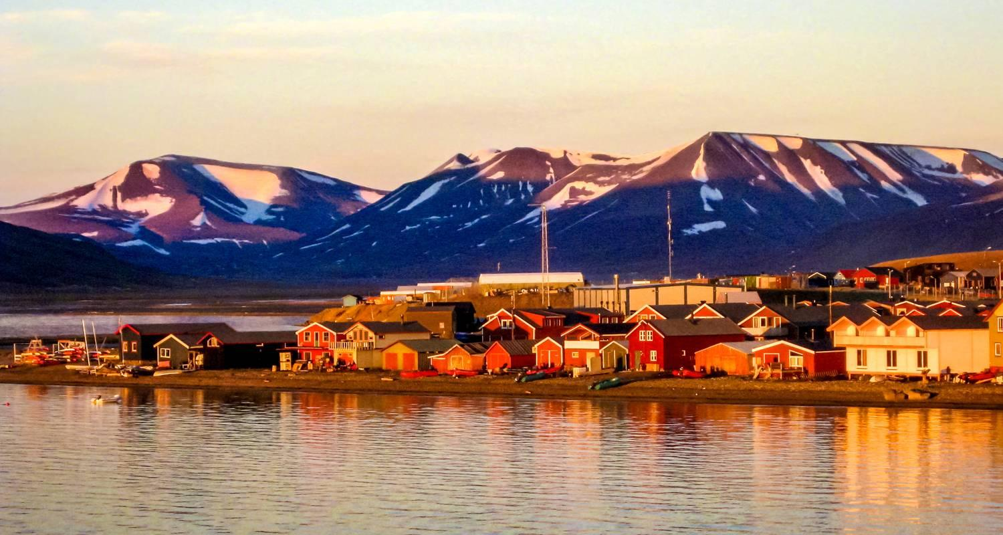



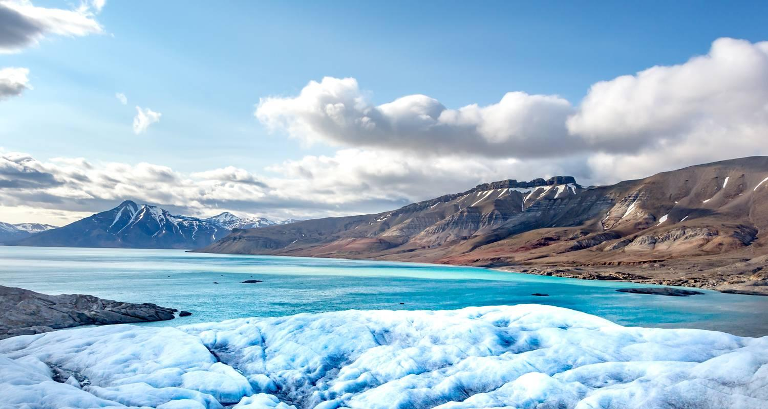

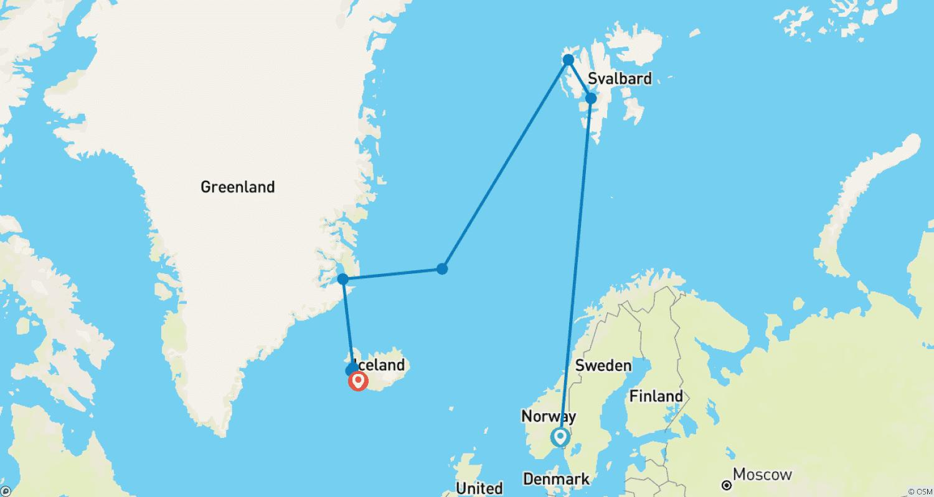

Tour ID: 259138  
Tour Name: Island Hopping In & Around the Arctic | Faroe Islands, Iceland, Spitsbergen: Northbound

Tour destinations: ['Bergen', 'Shetland Islands', 'Streymoy Island', 'Elduvík', 'Bakkagerdi', 'Husavik', 'Akureyri', 'Godafoss', 'Jan Mayen Island', 'Spitsbergen', 'Longyearbyen', 'Oslo']

Tour destinations images:

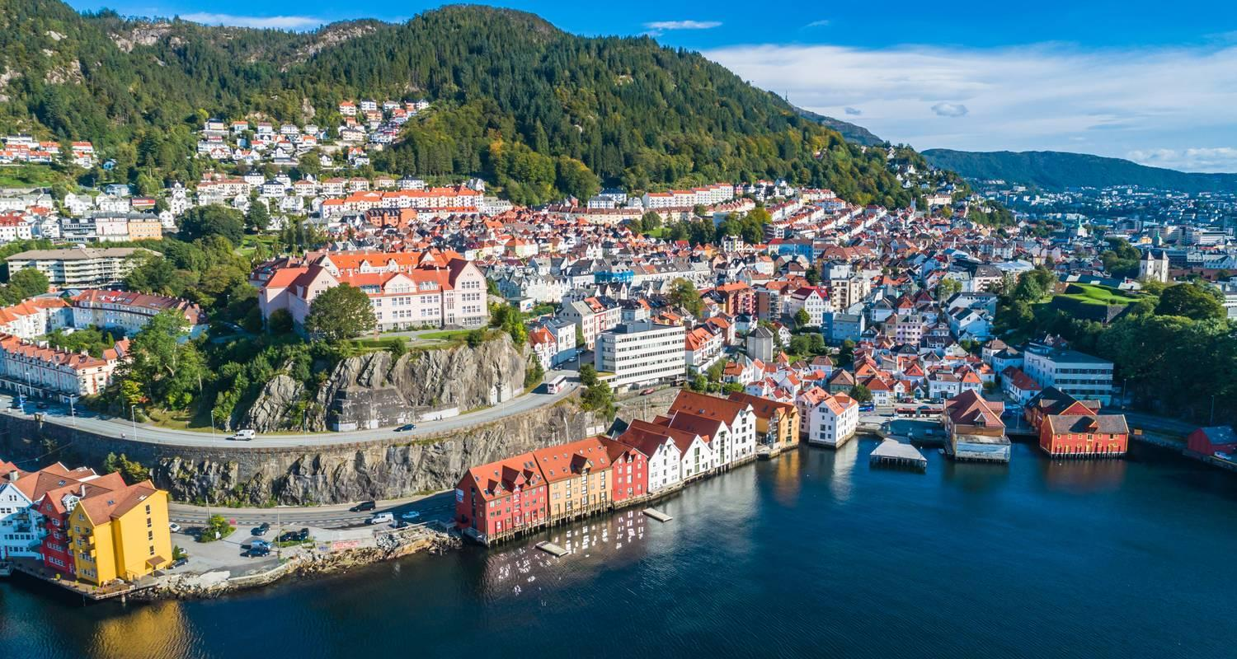

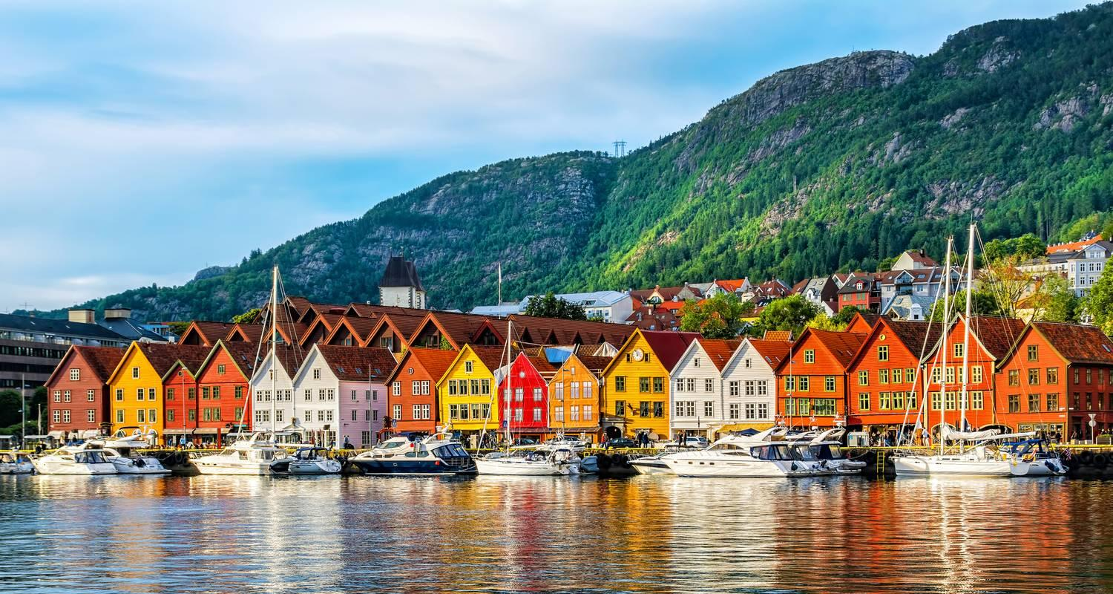

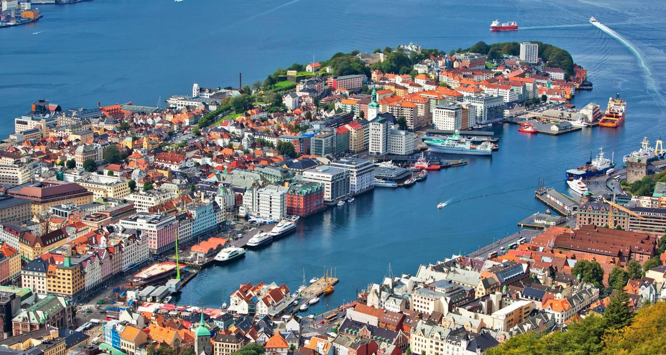



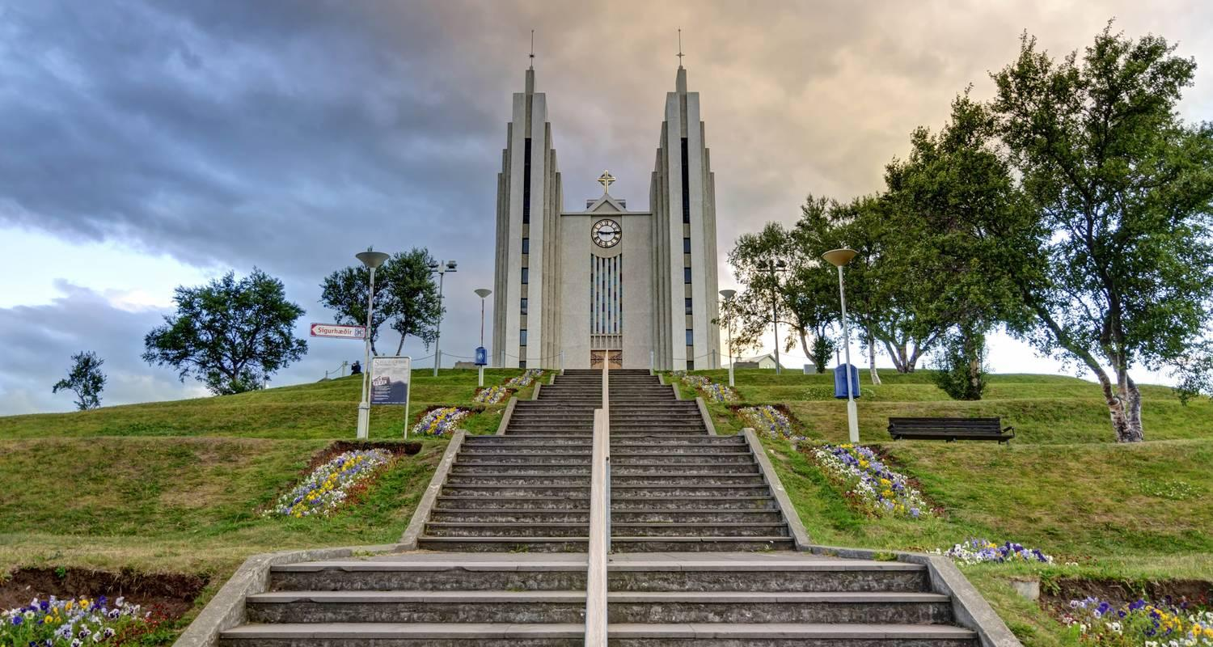





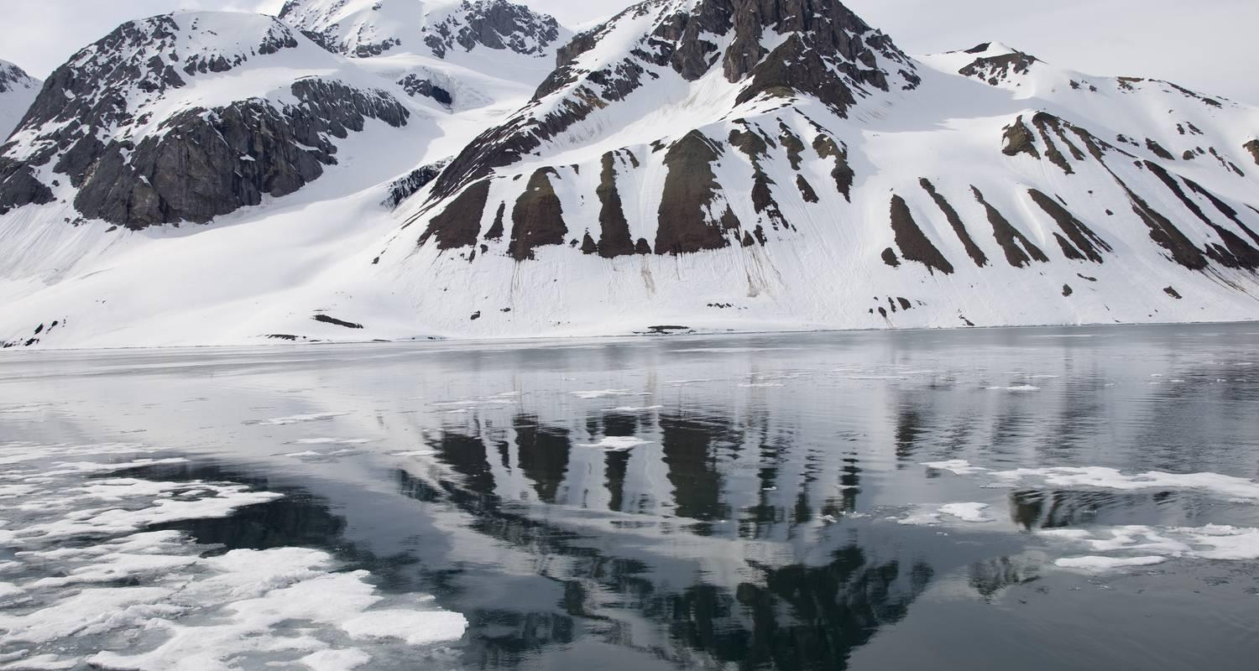





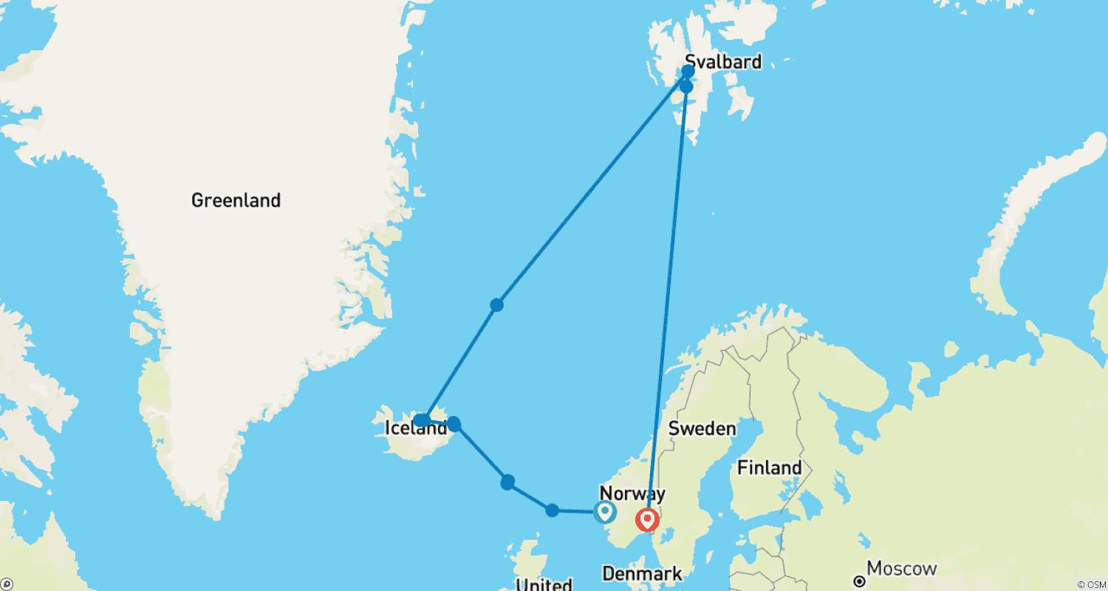

Tour ID: 259144  
Tour Name: The Arctic under the Midnight Sun | Iceland & Greenland

Tour destinations: ['Reykjavik', 'Stykkisholmur', 'Snæfellsnes', 'Patreksfjordur', 'Akureyri', 'Godafoss', 'Grimsey', 'Bakkagerdi', 'Heimaey Island', 'Qaqortoq', 'Sermersooq', 'Maniitsoq', 'Sisimiut', 'Ilulissat', 'Evighedsfjorden', 'Nuuk', 'Ivittuut']

Tour destinations images:











